

SCHOOL OF NATURAL SCIENCE AND SOCIAL SCIENCE

DEPARTMENT OF COMPUTER SCIENCE AND INFORMATION TECHNOLOGY

FINAL YEAR PROJECR 2022/2023

PROJECT TITLE: ONLINE SHOPPING AGRICULTURE MANAGEMENT SYSTEM.

PROJECT TYPE: WEB BASED PROJECT.

SUPERVISOR: DR HUSSEIN.

# DECLARATION

I declare to The State University of Zanzibar that is my own original work done within the period of registration and that it has neither been submitted nor being submitted in any other institute or university.

Ibrahim Juma Khamis. Date

………………………… ……./……/…………..

The above declaration is confirmed by:

Dr. Hussein Date

………………………… ……./……/…………..

(Supervisor)

# AKNOWLEDGEMENT

First of all, we should like to thanks Allah for give us good health on that time. Then we should like to thank all dear teachers to participate on that project from day one up to now.

Second, we are grateful to many individuals who contributed to Biziredi Veterinary Pharmacy and we wish to thank all of them for their contributions to the completion of this system;

Dr. Hussein, the State University of Zanzibar, Department of Computer Science (Project Supervisor).

Mr. Hamiar: The State University of Zanzibar, Department of Computer Science (Project coordinator).

Mr. Masoud Mmanga: The State University of Zanzibar, Department of Computer Science (Website Lecturer) Finally, we also appreciate the output of the entire group member since we have fully cooperating and giving suggestions during the conduct of the project. Once again, we would like to thank all those who helped in our project. Thanks everyone.

ABSTRACT

ONLINE SHOPPING AGRICULTURE MANAGEMENT SYSTEM is a software application that helps businesses manage their sales processes. It includes features such as lead tracking, customer relationship management, sales forecasting, and order management.

The system provides businesses with real-time information on their sales performance and helps them make better decisions about sales strategies, product pricing, and customer engagement. Also helps businesses with inventory management, sales reporting, and analysis. It is a powerful tool for improving sales productivity, profitability and customer satisfaction.

This document shows the procedure which used to create this system, source code as well as implementation.

##### CHEPTER 1: Introduction

1.1 DESCRIPTION OF THE PROJECT

Online Shopping Agriculture Management System(OSAMS) that under Biziredi Veterinary Pharmacy that work to manage their sales operations. It typically includes tools for tracking sales leads, managing customer relationships, generating sales reports and monitoring sales team performance. The goal of a sales management system is to increase efficiency and effectiveness in the sales process, leading to improve revenue and customer satisfaction.

1.2 BRIEF PROBLEM STATEMENT

There have been various developments of inventory management system in recent years, unfortunately there are still some problems facing them. The process of developing those systems found to be slow and often inaccurate, mostly because the systems could not keep up with sale’s demand. Thus, stock-outs, overstocks, and outdated materials and their associated costs were a constant problem. The present situation makes difficult for sales person to track down the available products and expiration date due to a lot of the manual system used. This situation causes a lot of time consuming. Also there are a lot of duplication of ordering and receiving of the products of various products or goods. Due to the explained problems, the online shopping agriculture management system has just comes up with an idea of introducing a technological management system which will not only help to solve their current problems but also help them on products management and improvement of their relationship with their customer.

##### PROBLEMS SOLUTION AND THE SCOPE

**Proposed Solutions**

The proposed system will be an automated by develop a computerized system that help businesses manage and optimize their sales processes. These system can provide a wide range of benefits, including improved of efficiency, better tracking and management of sales activities, enhanced customer relationship management, improved sale forecasting and analysis and increased sales revenue.

The proposed system will ensure that has proper security measures in place to protect against data breaches.

The Scope

The Scope of this project is limited to the activation of a Biziredi Veterinary Pharmacy which help businesses optimize their sales processes and drive revenue growth. These system typically include feature such as customer relationship management, forecasting, reporting and analytics.

* 1. MAIN AIM AND SPECIFIC OBJECTIVES

Main objectives

The main aim of the proposed system is to help businesses manage and streamline their sales processes effectively. This can involve automating sales-related tasks, tracking sales activities and progress, managing customer relationships, and providing sales analytics and reporting.

Specific Objectives

The specific objectives of this project are: -

* To make system easy to access information at a real time and accurate.
* To save cost and time during system processes occurs.
* To increase data performance (data retrieving).
* Centralized data and information management.
* To make system able to manipulate data automatically.
  1. PROJECT BACKGROUND AND MOTIVATION

The currently they have no automatic system that available from Biziredi Veterinary Pharmacy in order for tracking the product and the motivation is I come up with the system that will solve this process, those activities will be solved by using this system.

1.6 FEASIBILITY

Feasibility study were conducted in organization where requirements were collected at Biziredi Veterinary Pharmacy shops of agriculture.

The study area of our project is in the Local Communities in Zanzibar where the interview done through it.

**Technical**: It is visible because the proposed system will be very easy to interact with users and control it.

**Economic:** In propose system develop we use software that most of them are open sources, such as MySQL which is used to create database and script language is JAVA all of them no need of license when used.

**Operational:** To implement this project is possible since most of the sales person have laptop, so they can use this system anytime and anywhere if their Internet.

##### CHAPTER 2: METHODOLOGY

* 1. Software development approach (object oriented or structured)

In this project I approach on the Object-Oriented software development because: -

* Its bundle code into a single unit where you can determine the scope of each piece of data.
* The class can inherit attributes and behaviors from another class, you are able to reuse more code.
* One class can be used to create many objects, all from the same flexible piece of code.

## 2.2. Software development life cycle model (SDLC)

We appreciate to use agile model because this model allows changes when they are required (Time to time changes).

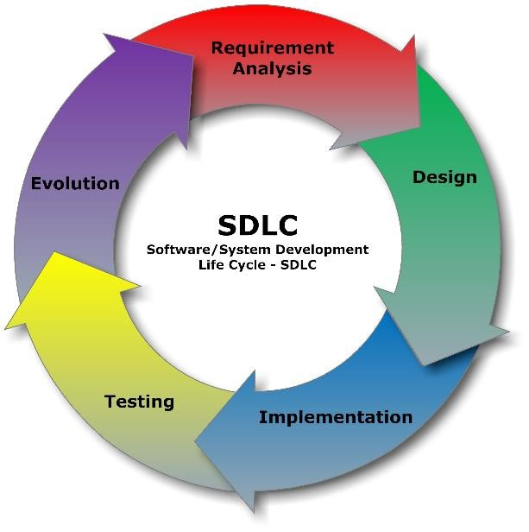

Figure 1:SDLC

## 2.3. System Architecture

The system architecture is Two tier Architecture, the Client side can access the system and get notification from the Server side and the Server side can send the result to the customers.

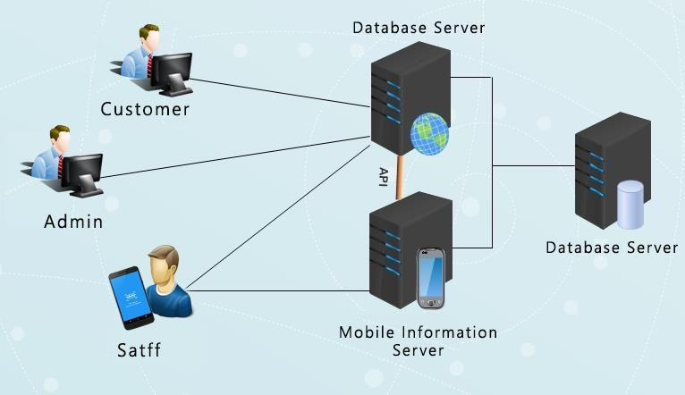

Figure 2: System Architecture

## 2.4. Software development tools

In this project we are going to use various software development tools concerning the front-end view and back-end view as following: -

Front-end – Java Jsp, HTML, CSS, Angular Frame work .

Backend – JAVA, Spring Boot.

# CHAPTER 3: REQUIREMENTS ANALYSIS AND MODELING

## 3.1 Requirement determination

In a feasibility study period, I have spent a lot of time for studying the function of the existing system and how it operates at the Shop, purposely to get the data in accuracy manner.

#### 3.1.1 Information gathering techniques

While gathering requirement I have used different techniques for collecting the needed requirements. These techniques are as followed:

* Interviews: interview was carried out through means of questions and answers with the client to determine what requirement is needed for the new system to be developed.
* Observation: also, an observation was done in order to determine the requirements by looking the processes that happen in the current system.
* Existing system reviews: an observation was also carried out to review some of the existing that are similar to the proposed system, in order to determine how the new system can be implemented.

#### 3.1.2 Functional requirement

This proposed project describes detailed and specific requirement of the project. It will also include the function requirement covering the functionalities expected by the users, a complete specification which describes all the functionalities of the system and non-functional requirements such as reliability, portability, accessibility, maintainability and usability.

* The system should have the capability to track inventory levels of products, and alert the user when stock is running low.
* The system should also be able to manage the pricing and stock levels of different products.
* The system should be able to receive and manage orders from customers, including the ability to track order status, update customers on order status, and manage returns and exchange
* The system should be able to store customer information, including contact details, order history, and payment details.
* The system should be able to generate reports and provide analytics on sales data, including revenue, customer trends, and product performance.

##### Non – functional requirement

* Usability: The system should be easy to use and navigate, with a user-friendly interface.
* Maintenance: The system should be easy to maintain and update, with minimal disruption to the business operations. It should have a system for providing regular updates and patches to fix bugs and security vulnerabilities.
* The FDI system shall allow notification to user when activity successes.

**other non-functional requirements**

**Performance Requirements:** This system is expected to have good performance and fast response time. When a user login, fill the product registration form, the system is expected to take not more than 20 seconds to respond.

**Safety Requirements:** For the safety of all data, the system will save the data of each product to the database once he/she submit. If the system crash, the system is expected to continue working fine when it is restarted and all the data that were saved before the crash will not be affected.

**Security Requirements:** This system will be secured for all data. The system will secure all users passwords with encryption, so that nobody else will be able to know the password. Also, this system will implement high level of data privacy. Only allow and authenticated users will be able to access the particular data on a particular time.